**Edward Lester Javier**

**Web Project Proposal**

**Meryenda.ca**

Mae’s All Day Meryenda / Merienda - Filipino Dishes, Snacks and Pastries.

Online Restaurant for Famous Filipino Delicacies.

Meryenda is a tagalog word that came from the Spanish word “merienda” which means snack.

Mae is the name of the chef / my wife.

**Website Name and Purpose**

The website will be named “Meryenda.ca”. The purpose of this site is to provide an online platform for my wife’s virtual Filipino restaurant, where customers can explore our menu and place orders for delivery or pick up. As we don’t have a physical store, our entire operation is based online, catering exclusively to online orders.

**Site Goals**

The primary goal of “Meryenda.ca” is to introduce and make Filipino cuisine accessible to a wider audience. Through our offering of Filipino foods and snacks, we also aim to create a sense of homecoming and happiness for those missing the Philippines. We will gauge our success by the surge in online orders, the influx of positive customer testimonials/feedback and the impressive turnout at our events.

**Target Audience**

Our target audience is broad, catering to food lovers of all ages who are open to trying Filipino cuisine. We expect that a significant fraction of our users will be career-oriented individuals who value the simplicity and convenience of online transactions. This also includes every individual who is longing for Filipino specialties and delicacies.

**Opportunity or Issue Addressed**

“Meryenda.ca” addresses the opportunity to introduce Filipino cuisine to a wider audience and provide a convenient platform for Filipino food ordering. It also enables us to keep our customers informed about our latest menu items, exclusive deals, and upcoming events.

**Content**

The website will include detailed descriptions of our dishes, high-quality images or short video clips of our food, and potentially video content showcasing the preparation of our signature dishes. We’ll also have sections dedicated to customer reviews and upcoming events.

**Related Sites**

Two related sites that offer similar services are DoorDash and Uber Eats. These platforms provide online food ordering services from a variety of restaurants. However, “Meryenda.ca” will offer a more personalized experience as it is dedicated solely to our online Filipino restaurant.

**Web Project Planning analysis:**

**Desired Results**

The desired result is to create a user-friendly, engaging, and efficient online platform for customers to explore and order Filipino cuisine from “Meryenda.ca”. The website should increase Filipino food popularity, reach a wider audience, and boost online sales.

**Page Titles**

Here are the titles of the pages on the site:

1. Home
2. Menu
3. Order Now
4. About Us

**Content Information:**

The content for the web pages will be sourced as follows:

* Text content will be written by me including input from the chef.
* Actual images of dishes will be photographed in high resolution.
* The logo and other branding elements will be designed by us.
* Customer reviews will be collected from feedback provided by customers.

**Schedule**:

* Week 1-2: Content collection and Brainstorming (Menu details, Pricing, Images, etc.)
* Week 3: Website design and development
* Week 4: Testing, debugging, gathering of feedback
* Week 5: Site launch

**Web Project Site Map:**

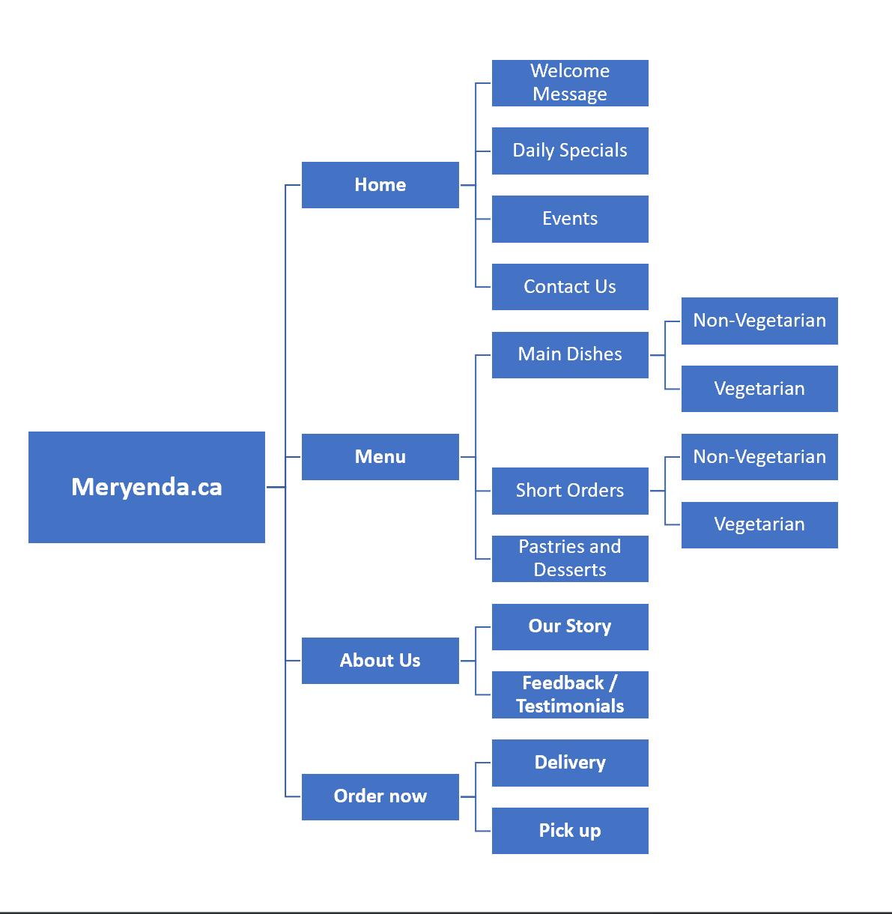

**Meryenda.ca**

* **Home**
  + Welcome Message
  + Daily Specials / Featured Dishes
  + Events
  + Contact Us
* **Menu**
  + Main Dishes
    - Non-Vegetarian
    - Vegetarian
  + Short Orders
    - Non-Vegetarian
    - Vegetarian
  + Pastries and Desserts
* **Order now**
  + Delivery
  + Pickup
* **About Us**
  + Our Story / the Chef
  + Feedback / Testimonials

**Web Project Page Layout Design:**

Below is the Website’s Page Layout:

